Toko Trailers Ltd

**“SIDE BY SIDE” ATV TRAILER**

**$5460.00 Inc GST**

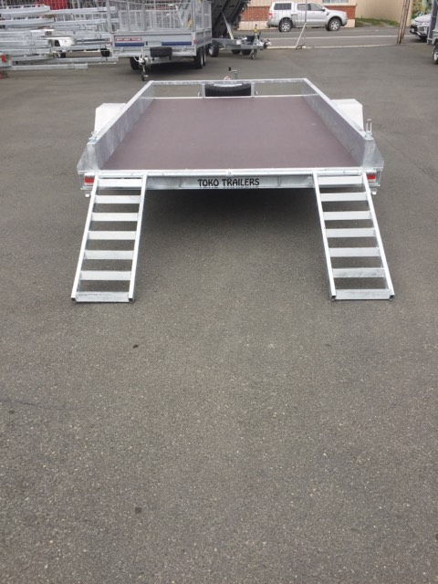 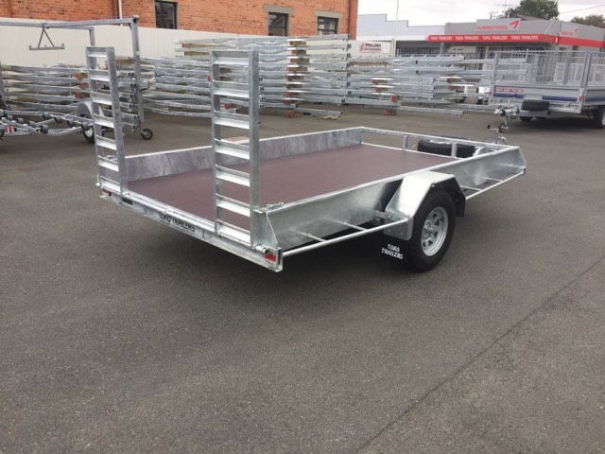

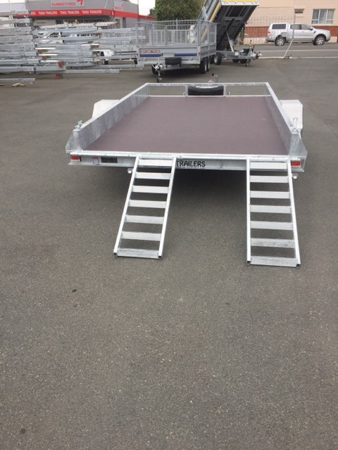**Features**:

* 3.2m x 1.8m Deck Size
* Fully Hot Dip Galvanised
* 1500kg Springs
* 13” Light Truck Tyres
* LED Lights
* GVM: 1500kg

**Extras**:

* Alloy Deck - $519.00
* Mag Wheels - $258.00 each
* Mounted Spare Wheel - $260.00
* Standard Ramps (Pictured) - $592.00
* Curved Ramps - $721.00

*\* All Pricing is inclusive of GST and subject to change without notice.*

**97 Union Street, Milton Ph: (03) 417-8727**

**www.tokotrailers.co.nz tokotrailers@xtra.co.nz**

**97 Union Street, Milton Ph: (03) 417-8727**

**www.tokotrailers.co.nz tokotrailers@xtra.co.nx**